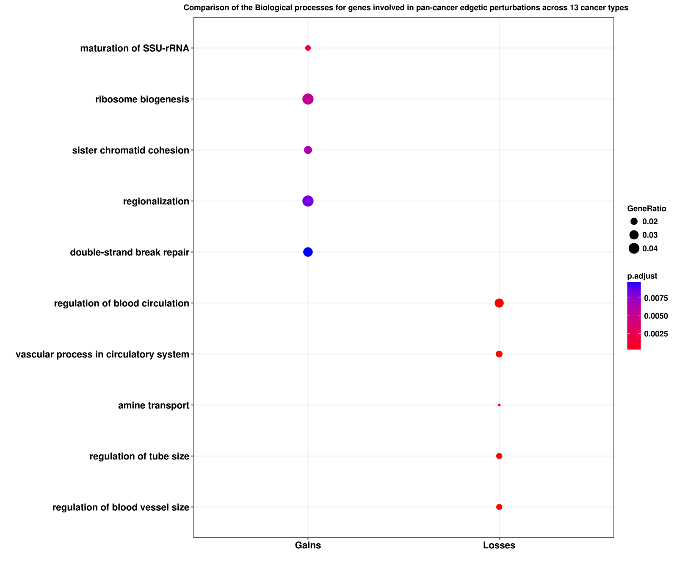

Supplementary Figure 11a. Differential biological processes under selection because of lost/gained edges across 13 cancer types. p.adjust - bonferroni corrected p-value (*<*0.05). The red or blue dots indicate the proportion of proteins involved in a specific biological process in a cancer type relative to the other cancer types.

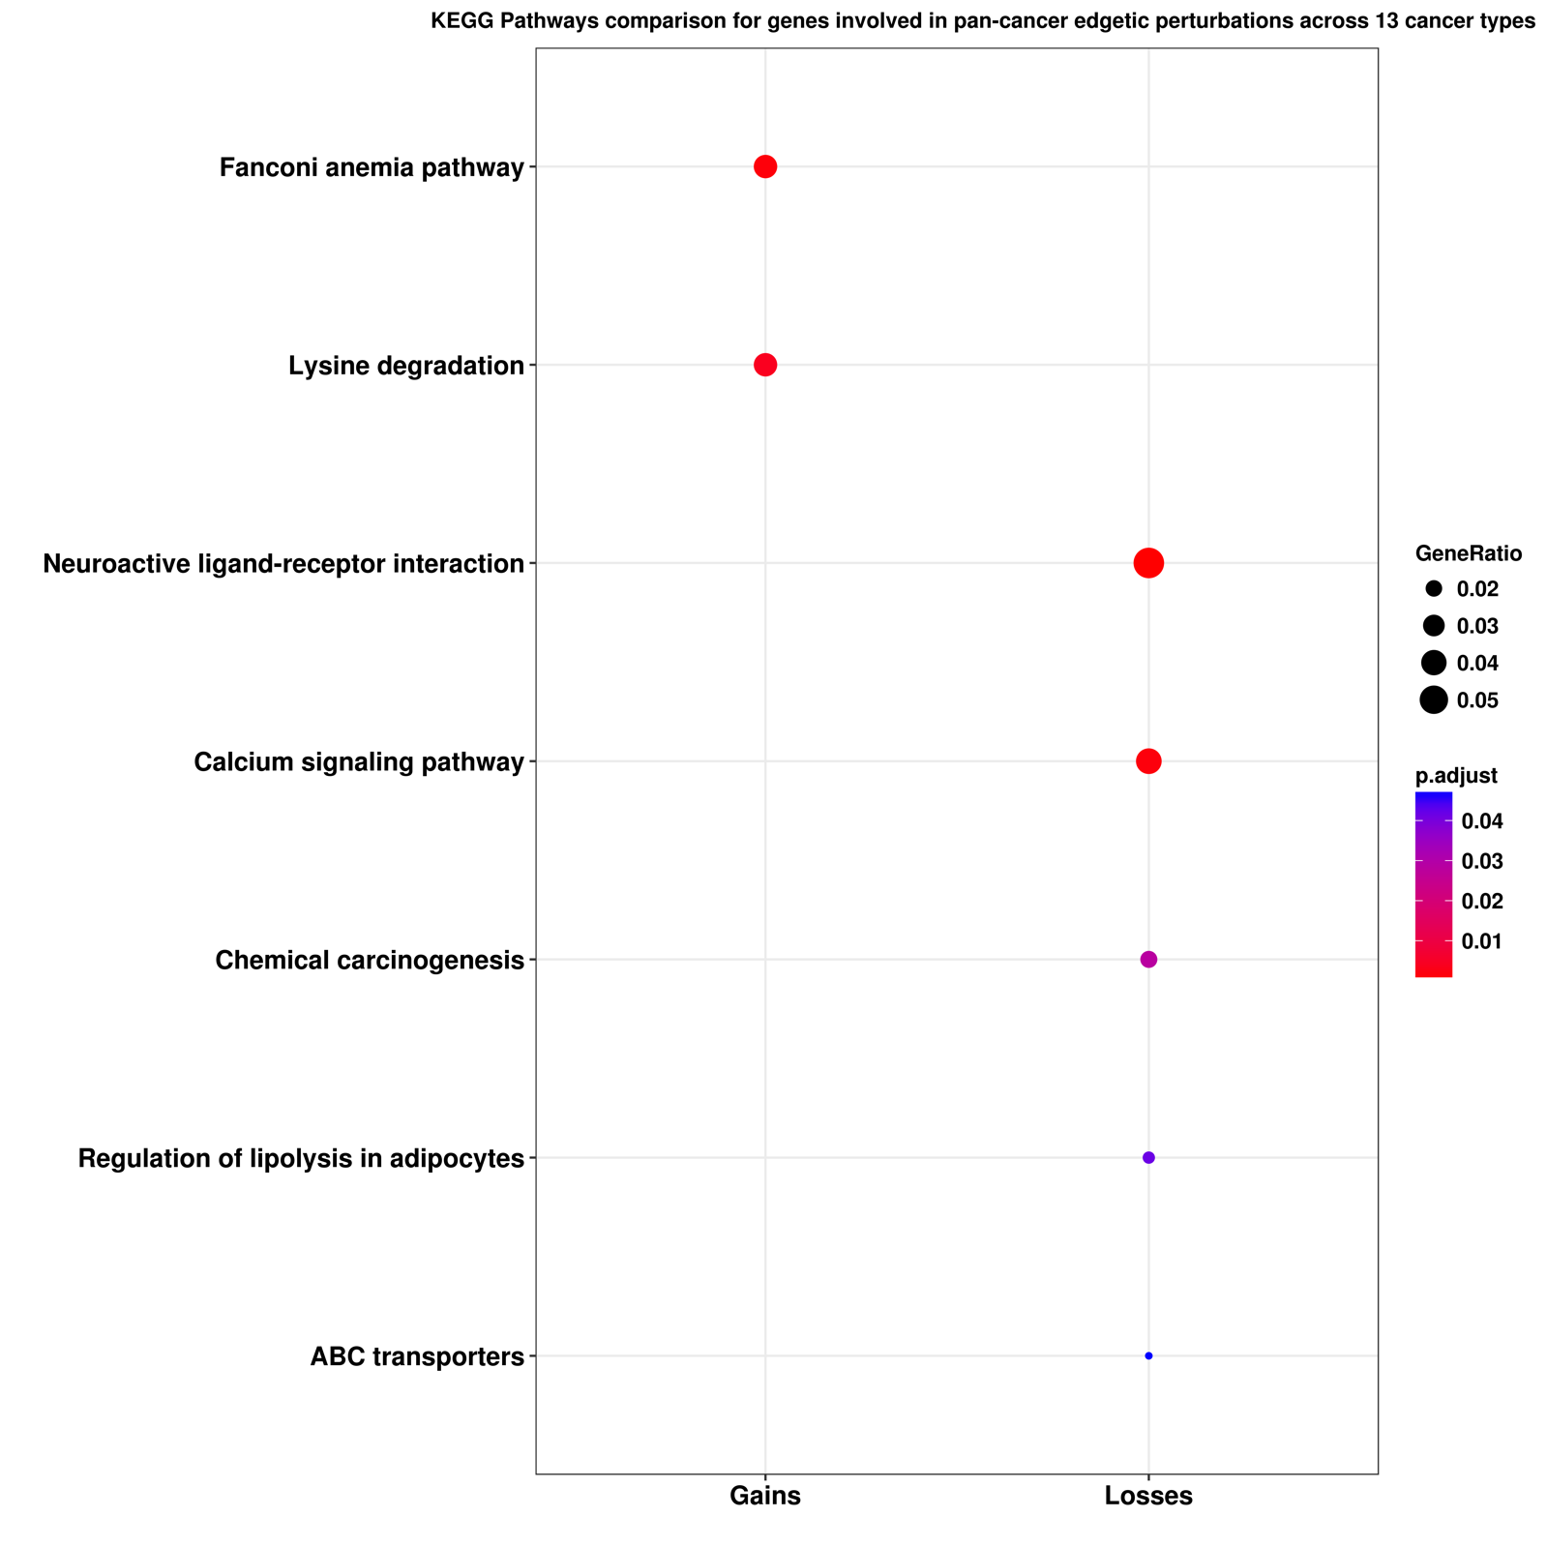

Supplementary Figure 11b. Differential KEGG pathways under selection because of lost/gained edges across 13 cancer types. p.adjust - bonferroni corrected p-value (*<*0.05). The red or blue dots indicate the proportion of proteins involved in a specific pathway in a cancer type relative to the other cancer types.